Day 16 (11 July 2025)
112552596 - vsisukhw - Sukhwinder Singh

For tasks questions , refer
https://docs.google.com/document/d/1RzFy1_TxUyOCFf2JkMVy9iC0W2-oQPk5xwbbve5pz0M/edit?tab=t.0

Task 1

Algorithm:
- Start with the array of size n.
- Repeat the following steps for i = n-1 down to 0:
  - Assume the maximum element's index is max = i.
  - Compare all elements from index 0 to i - 1.
  - If any element arr[j] is greater than arr[max], update max = j.
  - After inner loop, swap arr[max] with arr[i].
- Repeat this until the entire array is sorted.
- Print the sorted array.

Task 2
Pseudocode:
Function SelectionSort(arr, n):
for i from n-1 down to 0:
max ← i

for j from 0 to i-1:
if arr[j] > arr[max]:
max ← j

Swap arr[max] and arr[i]

Print all elements in arr

Task 3
Code:

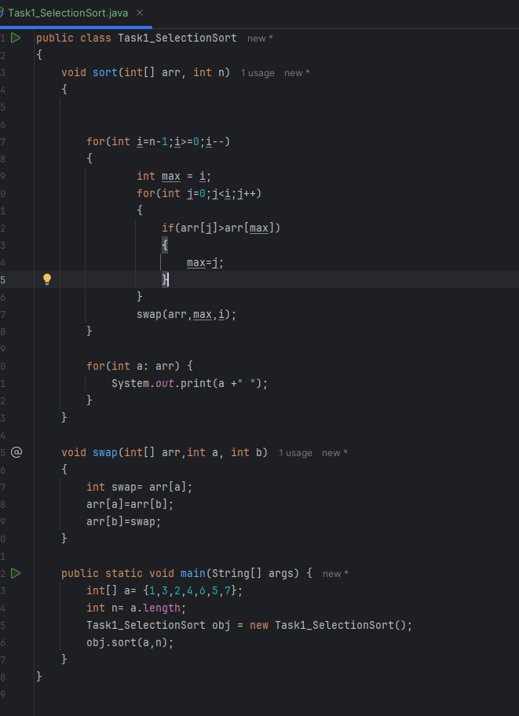
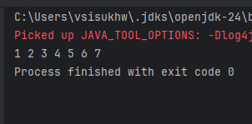

Task 4

Algorithm:
- Start with an array of size n.
- Repeat the following for i from n-1 down to 0:
  - For each j from 0 to i-1:
    - Compare arr[j] and arr[j+1].
    - If arr[j] > arr[j+1], swap them.
- After each outer loop pass, the largest element moves to its correct position.
- Repeat this until the array is fully sorted.
- Print the sorted array.

Task 5
Pseudocode:
Function BubbleSort(arr, n):
for i from n-1 down to 0:
for j from 0 to i-1:
if arr[j] > arr[j+1]:
Swap arr[j] and arr[j+1]

Print all elements of arr

Task 6
Code:
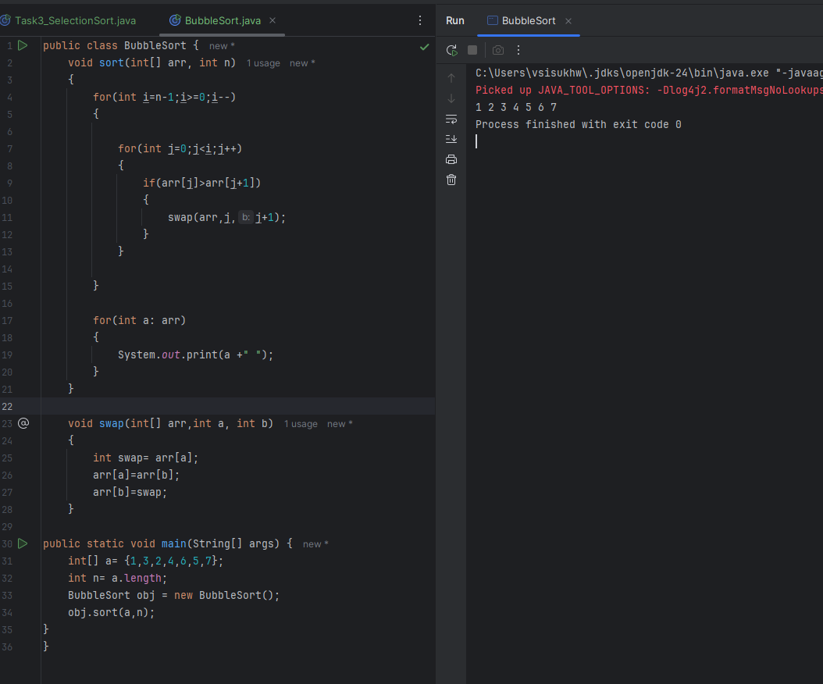

Task 7

Algorithm :
- Start with the second element (index 1) of the array.
- Store this element in a temporary variable called next.
- Compare next with each element in the sorted part of the array (from right to left).
- While the current element is greater than next, shift it one position to the right.
- Once a smaller element is found (or beginning of array is reached), insert next at that position.
- Repeat this for all elements in the array.
- Print or return the sorted array.

Task 8
Pseudocode:
Function insertionSort(array a, integer n)
for i ← 1 to n - 1 do
next ← a[i]
j ← i - 1

while j ≥ 0 and a[j] > next do
a[j + 1] ← a[j]
j ← j - 1
end while

a[j + 1] ← next
end for

Print array a
End Function

Task 9
Code:
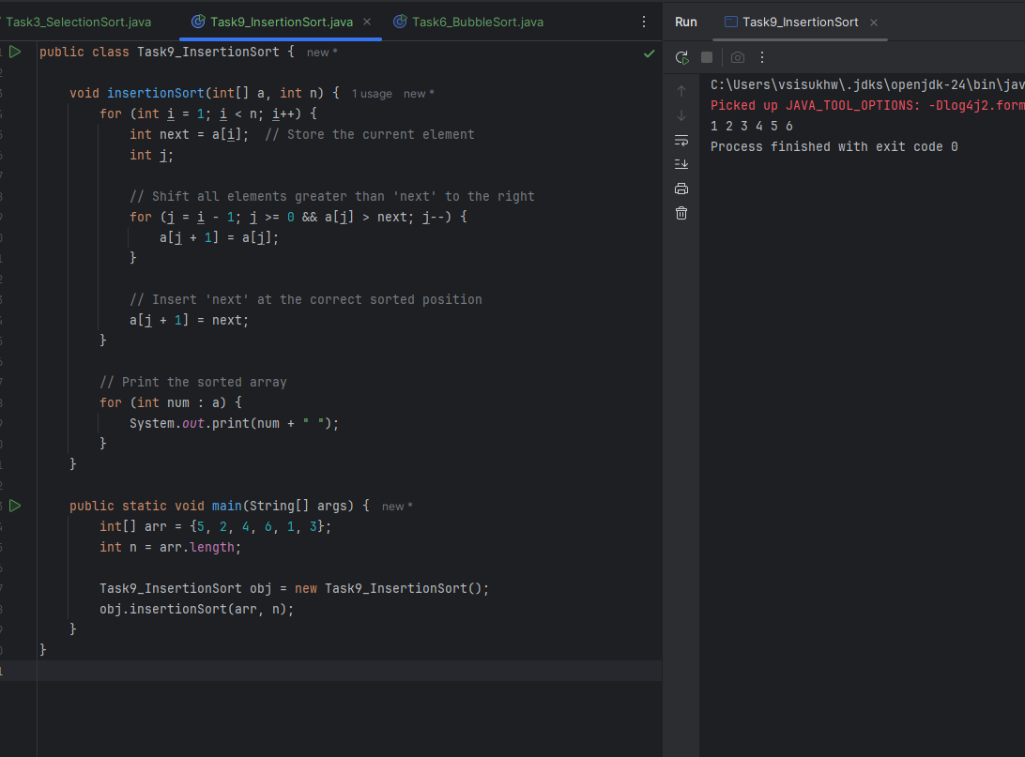

Task 10

Advantages of Bubble Sort:
- Very easy to understand and implement.
- Works in-place (no extra memory needed).
- Stable sort (keeps equal elements in order).
- Can detect already sorted arrays with optimization.
- Best case is fast (O(n)) when array is already sorted.

Disadvantages (Limitations):
- Very slow for large data (O(n²) time complexity).
- Performs too many unnecessary swaps.
- Not efficient even if the array is partially sorted.
- Not used in real-world applications.
- Much slower than other sorting algorithms like Quick Sort or Merge Sort.

Task 11
This code is going overflow of stack.. Can you fix it..

public class RecLoop {

public int calc(int n) {
if (n == 0) return 0;
return n + calc(n);
}

This code causes a stack overflow because of infinite recursion.
We are calling calc(n) with the same n every time.
So n never becomes 0, and the recursion never stops.
This leads to a stack overflow error.

Correct Way:

public class RecLoop {

public int calc(int n) {
if (n == 0) return 0;
return n + calc(n-1);
}

Task 12

Algorithm:
- Start with the input array and two indices: left and right.
- If left is less than right:
  - Find the mid point of the array.
  - Recursively apply merge sort to the left half (left to mid).
  - Recursively apply merge sort to the right half (mid + 1 to right).
  - Merge the two sorted halves using a merge procedure.
- In the merge step:
  - Create two temporary arrays for left and right halves.
  - Compare elements of the two arrays and place the smaller element back into the original array.
  - Copy any remaining elements from both arrays.
- Continue recursively until the whole array is sorted.

Task 13
Pseudocode:
Procedure mergeSort(arr, left, right)
If left < right then
mid ← (left + right) / 2

mergeSort(arr, left, mid)
mergeSort(arr, mid + 1, right)

merge(arr, left, mid, right)
End If
End Procedure

Procedure merge(arr, left, mid, right)
n1 ← mid - left + 1
n2 ← right - mid

Create arrays L[0..n1-1] and R[0..n2-1]

For i from 0 to n1 - 1
L[i] ← arr[left + i]

For j from 0 to n2 - 1
R[j] ← arr[mid + 1 + j]

i ← 0, j ← 0, k ← left

While i < n1 and j < n2
If L[i] ≤ R[j]
arr[k] ← L[i]
i ← i + 1
Else
arr[k] ← R[j]
j ← j + 1
End If
k ← k + 1
End While

While i < n1
arr[k] ← L[i]
i ← i + 1
k ← k + 1
End While

While j < n2
arr[k] ← R[j]
j ← j + 1
k ← k + 1
End While
End Procedure

Task 14
Code:
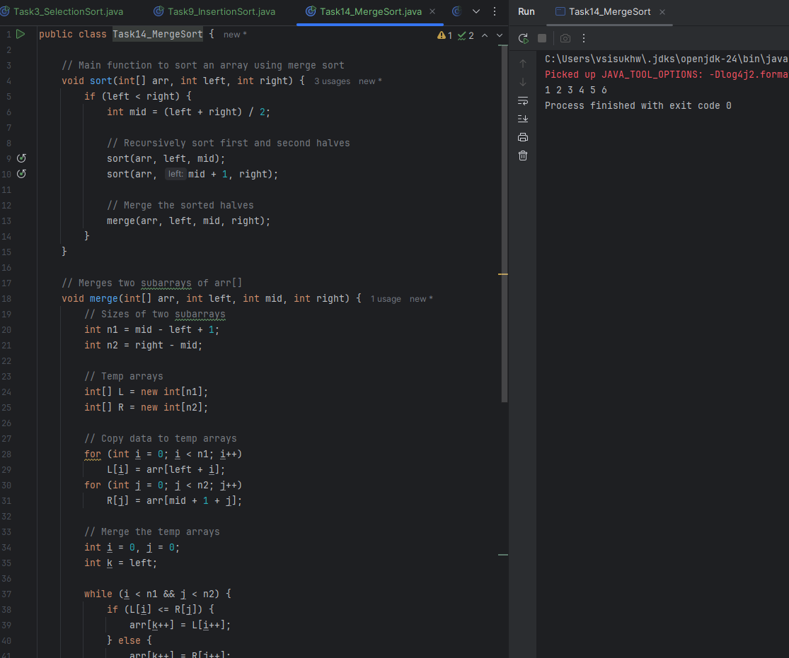
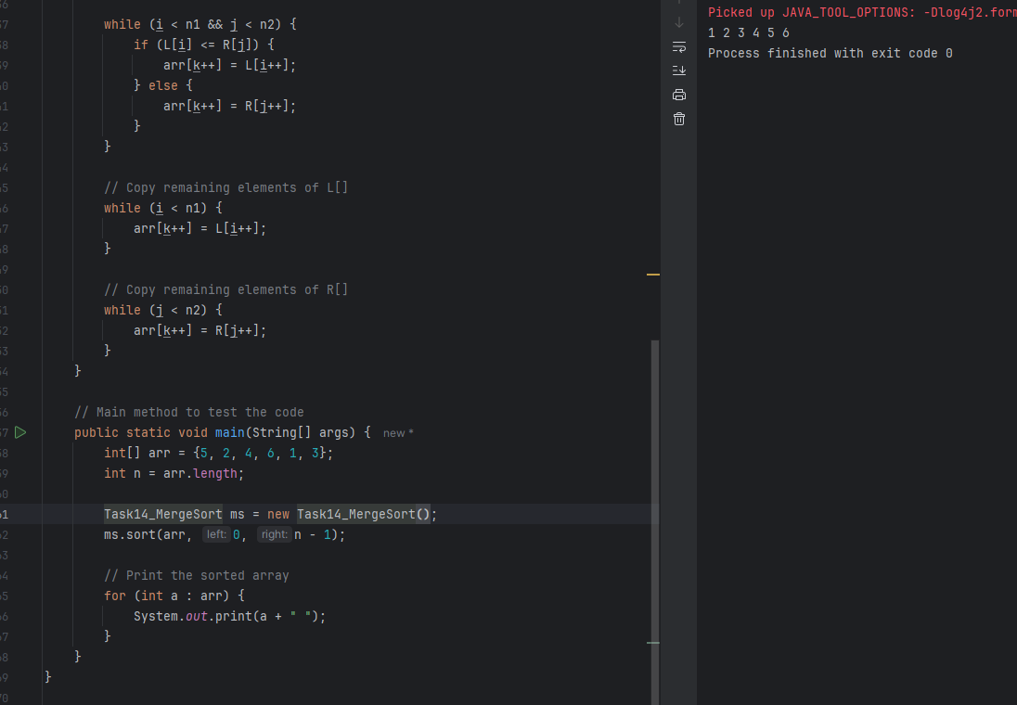

Task 15

Algorithm:
- Choose a pivot element from the array (commonly the last element).
- Partition the array:
  - All elements smaller than the pivot go to the left.
  - All elements greater than the pivot go to the right.
- Recursively apply the same logic to the left and right subarrays.
- Continue until each subarray has one or zero elements (base case).

Task 16
Pseudocode:
Procedure quickSort(arr, low, high)
if low < high then
pivotIndex ← partition(arr, low, high)
quickSort(arr, low, pivotIndex - 1)
quickSort(arr, pivotIndex + 1, high)
end if
End Procedure

Procedure partition(arr, low, high)
pivot ← arr[high]
i ← low - 1

for j ← low to high - 1 do
if arr[j] < pivot then
i ← i + 1
swap arr[i] and arr[j]
end if
end for

swap arr[i + 1] and arr[high]
return i + 1
End Procedure

Task 17
Code:
